Torah Questions for Discussion Numbers 1:1-4:20
1 | 1:1 “Adonai spoke to Moshe in the Sinai Desert…” The wilderness typically is a hostile environment, without food, water, or shade, devoid of life, but we can learn from this portion of scripture that there is great revelation, speaking specifically of the giving of Torah. One doesn’t need material things or physical pleasure to receive great treasures of truth; being in a desert place does not restrict us from receiving high levels of consciousness and blessing. (Lev 27.34) If a person does not make himself like a wilderness, he will not be able to acquire the wisdom of Yahweh’s teaching. (Mt 18.3, John 12.24-25, 2Co 12.9-11) Having a weakness of soul (Strong’s G769) is a perquisite, to be restrained from corrupt desire and to understand the teachings of Adonai, then to receive the capacity to obtain strength of the Lord.  - Should you feel vulnerable when revealing your weakness to Adonai?  - Do you bring your own solutions to your desert place? Are you willing to allow Elohim to examine your needs then bless you?  1:2 Moshe was instructed to take the first census, to ascertain the size of each tribe here in B’midbar. This census wasn’t for political or national economic reason, but to fulfill Adonai’s instructions. Each person was to be counted, regardless of their status, their appearance, or their accomplishments, they were the sheep of YHVH’s pasture (Ps 79.13, 100.3), it created a sense of unity, each person being a part of a greater purpose. The census determined the number of capable fighting men, just as every believer is a representative of a Spiritual army. (Luke 9.1; 10.19, 2 Co 10.3-6, 1 John 2.14, Rev 12.11) This wilderness census also illustrates the family structure and relationship. The hierarchical family relationship reveals the patriarchal, a strong central position of fathers; each tribe was the descendent of Jacob (Israel) with one common father Yahweh. In the gospels, the apostle Paul was eager to establish spiritual paternity for believers in Y’shua, they needed to understand their patriarchal family and the great riches of inheritance (Romans 8.15, 23; 9.4)  - Are you fulfilling your role as a Spiritual warrior, helping to advance the kingdom of HaShem?  - In what ways have you proven that you value your spiritual paternity?
2 | 1:53 The Levites were instructed to camp around the Tabernacle so the wrath of Adonai would not fall upon the congregation. Adonai distinguished the tribe of Levi for a special position of service because of their faithfulness to Him in the golden calf episode (Ex 32.8) and their zeal for defending Isra’el against idolatry. (Mt 10.39; 23.11, Lu 22.26, 27, John 13.14, 15)  - Each of us is to walk in the footsteps of the tribe of Levi, having zeal for the holiness of Hashem and His people. Are you willing to walk in this difficult path even when it’s you who is building a golden calf?  2:1-34 Adonai said to Moshe and Aharon, the people of Isra’el are to set up camp by clans, each man with his own banner and under his clan’s symbol…” The Tabernacle, which held the presence of YHVH, was positioned in the very center of the camp and is a copy of YHVH’s glorious throne in heaven, where all activity is directed and focused. (Rev 4.2, 9; 5.6; 7.11) The tribes (see page 3) to the east toward the sunrise were under the banner of Y’hudah (lion), those to the south, were under the banner of Re’uven (man), to the west was Efrayim (ox) and the north was Dan (eagle), each one representing the four-living creatures in Ezekiel 1.5-10, and the Tabernacle and its furniture are copies of the original. (Heb. 9.23,24) Yet as we look carefully at the structure of the camp, we can see the picture of Y’shua on the cross; He was hidden in plain sight yet has now been revealed to us who are believers in Y’shua. (Lu 12.2, 1Co 2.7, Eph. 3.9, Col 1.26)  - Is Y’shua the focus point of everything in your life?
3 | 4:3 “…all those from thirty to fifty years old; these will enter the corps doing the work in the tent of meeting.” Adonai demanded the best years (30-50 age) of the Levites to be employed in the ministry of the Tabernacle.  - Are you giving your best years to Adonai or leftovers, pursuing your own interests?  - Has trauma stifled your ability to offer yourself in pure ministry to the Most High?  4:4-20 Adonai gives instructions to Moshe and Aharon on how they are to service the Tabernacle, He requires them to obey His commands.  - Is obeying Adonai and keeping His commands enjoyable, or is it a burden to you? (John 14.15, 21 1 John 5:1-3)

Brit Hadashah 1 Corinthians 12.12-31 3 Points

1)

2)

3)

How does the Brit Hadashah communicate the PARASHAH?

______________________________________________________________________________________

______________________________________________________________________________________

______________________________________________________________________________________

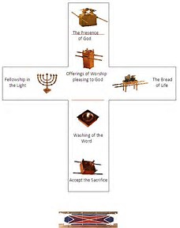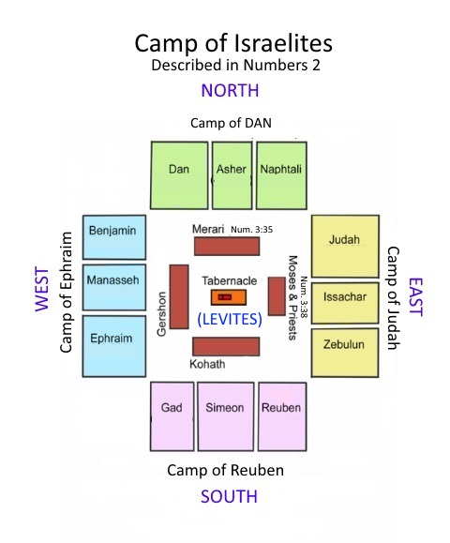

Location | Tribe | Symbol |  | Gospel | Scripture
EAST | JUDAH | LION | Ruler over all | Matthew-King Messiah | Rev 5.5
NORTH | DAN | EAGLE | influence spiritual realm | John-Son of YHVH | Ex 19.4, Jer 48.40
WEST | EPHRAIM | OX | Submit to yoke of YHVH | Mark-Servant | Hos 4.16; 10.11, Isa 42.1
SOUTH | RUBEN | MAN | Striving to attain | Luke-Son of Man | Gen 1.26, Dan 7.13

Ezk.1:10, Rev 4:6-8 (esp. 7)

